**Exercise 1: Control Structures**

**Scenario 1: The bank wants to apply a discount to loan interest rates for customers above 60 years old.**

**Code:**

CREATE TABLE Customers (

customer_id NUMBER PRIMARY KEY,

name VARCHAR2(100),

age NUMBER,

balance NUMBER,

isVIP CHAR(1) DEFAULT 'N'

);

CREATE TABLE Loans (

loan_id NUMBER PRIMARY KEY,

customer_id NUMBER,

interest_rate NUMBER,

due_date DATE,

FOREIGN KEY (customer_id) REFERENCES Customers(customer_id)

);

INSERT INTO Customers (customer_id, name, age, balance, isVIP) VALUES (1, 'Doe', 65, 15000, 'Y');

INSERT INTO Customers (customer_id, name, age, balance, isVIP) VALUES (2, 'Jane ', 65, 12000, 'N');

INSERT INTO Customers (customer_id, name, age, balance, isVIP) VALUES (3, 'Brown', 70, 20000, 'Y');

INSERT INTO Customers (customer_id, name, age, balance, isVIP) VALUES (4, 'Emily', 40, 9000, 'N');

INSERT INTO Customers (customer_id, name, age, balance, isVIP) VALUES (5, 'Michael', 30, 18000, 'Y');

INSERT INTO Loans (loan_id, customer_id, interest_rate, due_date) VALUES (101, 1, 5, TO_DATE('2024-12-31', 'YYYY-MM-DD'));

INSERT INTO Loans (loan_id, customer_id, interest_rate, due_date) VALUES (102, 2, 9, TO_DATE('2024-11-30', 'YYYY-MM-DD'));

INSERT INTO Loans (loan_id, customer_id, interest_rate, due_date) VALUES (103, 3, 5, TO_DATE('2024-10-15', 'YYYY-MM-DD'));

INSERT INTO Loans (loan_id, customer_id, interest_rate, due_date) VALUES (104, 4, 1, TO_DATE('2024-09-10', 'YYYY-MM-DD'));

INSERT INTO Loans (loan_id, customer_id, interest_rate, due_date) VALUES (105, 5, 8, TO_DATE('2024-08-25', 'YYYY-MM-DD'));

BEGIN

FOR rec IN (

SELECT loan_id

FROM Loans

WHERE customer_id IN (

SELECT customer_id FROM Customers WHERE age > 60

)

) LOOP

UPDATE Loans

SET interest_rate = interest_rate - 1

WHERE loan_id = rec.loan_id;

END LOOP;

END;

/

SELECT l.loan_id, l.customer_id, l.interest_rate, l.due_date, c.age

FROM Loans l

JOIN Customers c ON l.customer_id = c.customer_id;

**Output:**

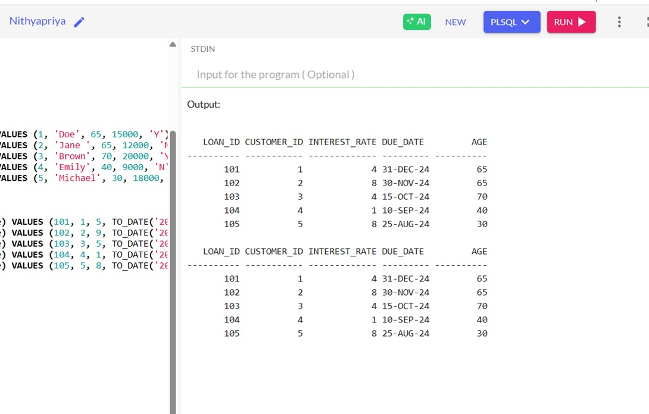

**Scenario 2: A customer can be promoted to VIP status based on their balance.**

**Code:**

CREATE TABLE Customers (

customer_id NUMBER PRIMARY KEY,

name VARCHAR2(100),

age NUMBER,

balance NUMBER,

isVIP CHAR(1) DEFAULT 'N'

);

CREATE TABLE Loans (

loan_id NUMBER PRIMARY KEY,

customer_id NUMBER,

interest_rate NUMBER,

due_date DATE,

FOREIGN KEY (customer_id) REFERENCES Customers(customer_id)

);

INSERT INTO Customers (customer_id, name, age, balance, isVIP) VALUES (1, 'Doe', 65, 15000, 'N');

INSERT INTO Customers (customer_id, name, age, balance, isVIP) VALUES (2, 'Jane', 65, 12000, 'N');

INSERT INTO Customers (customer_id, name, age, balance, isVIP) VALUES (3, 'Brown', 70, 20000, 'N');

INSERT INTO Customers (customer_id, name, age, balance, isVIP) VALUES (4, 'Emily', 40, 9000, 'N');

INSERT INTO Customers (customer_id, name, age, balance, isVIP) VALUES (5, 'Michael', 30, 18000, 'N');

INSERT INTO Loans (loan_id, customer_id, interest_rate, due_date) VALUES (101, 1, 5, TO_DATE('2024-12-31', 'YYYY-MM-DD'));

INSERT INTO Loans (loan_id, customer_id, interest_rate, due_date) VALUES (102, 2, 9, TO_DATE('2024-11-30', 'YYYY-MM-DD'));

INSERT INTO Loans (loan_id, customer_id, interest_rate, due_date) VALUES (103, 3, 5, TO_DATE('2024-10-15', 'YYYY-MM-DD'));

INSERT INTO Loans (loan_id, customer_id, interest_rate, due_date) VALUES (104, 4, 1, TO_DATE('2024-09-10', 'YYYY-MM-DD'));

INSERT INTO Loans (loan_id, customer_id, interest_rate, due_date) VALUES (105, 5, 8, TO_DATE('2024-08-25', 'YYYY-MM-DD'));

BEGIN

FOR rec IN (

SELECT customer_id, balance

FROM Customers

) LOOP

IF rec.balance > 10000 THEN

UPDATE Customers

SET isVIP = 'Y'

WHERE customer_id = rec.customer_id;

END IF;

END LOOP;

COMMIT;

END;

/

SELECT l.loan_id, l.customer_id, l.interest_rate, c.balance,l.due_date, c.isVIP

FROM Loans l

JOIN Customers c ON l.customer_id = c.customer_id;

**Output:**

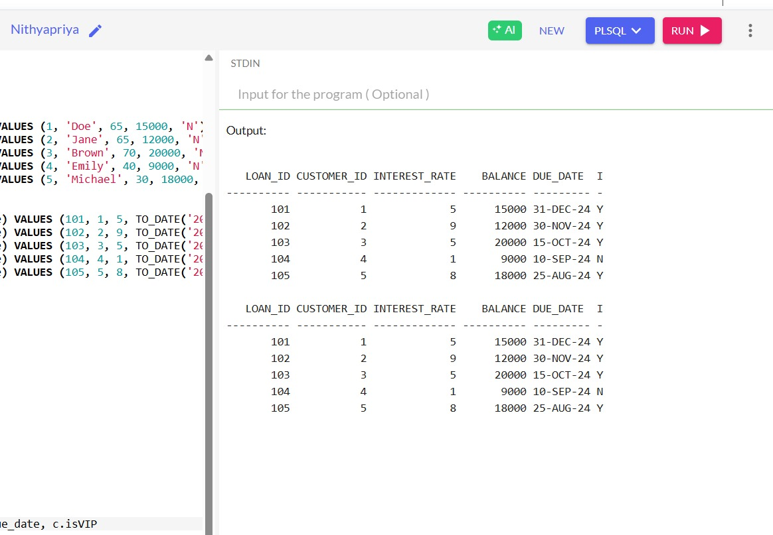

**Scenario 3: The bank wants to send reminders to customers whose loans are due within the next 30 days.**

**Code:**

CREATE TABLE Customers (

customer_id NUMBER PRIMARY KEY,

name VARCHAR2(100),

age NUMBER,

balance NUMBER,

isVIP CHAR(1) DEFAULT 'N'

);

CREATE TABLE Loans (

loan_id NUMBER PRIMARY KEY,

customer_id NUMBER,

interest_rate NUMBER,

due_date DATE,

FOREIGN KEY (customer_id) REFERENCES Customers(customer_id)

);

INSERT INTO Customers (customer_id, name, age, balance, isVIP) VALUES (1, 'Alice', 72, 2000, 'N');

INSERT INTO Customers (customer_id, name, age, balance, isVIP) VALUES (2, 'Bob', 64, 18000, 'N');

INSERT INTO Customers (customer_id, name, age, balance, isVIP) VALUES (3, 'Davis', 68, 200, 'N');

INSERT INTO Customers (customer_id, name, age, balance, isVIP) VALUES (4, 'Martin', 42, 109500, 'N');

INSERT INTO Customers (customer_id, name, age, balance, isVIP) VALUES (5, 'Clark', 38, 1300, 'N');

-- Insert loans into the Loans table

INSERT INTO Loans (loan_id, customer_id, interest_rate, due_date) VALUES (101, 1, 6, TO_DATE('2025-01-15', 'YYYY-MM-DD'));

INSERT INTO Loans (loan_id, customer_id, interest_rate, due_date) VALUES (102, 2, 7, TO_DATE('2025-02-28', 'YYYY-MM-DD'));

INSERT INTO Loans (loan_id, customer_id, interest_rate, due_date) VALUES (103, 3, 8, TO_DATE('2025-03-10', 'YYYY-MM-DD'));

INSERT INTO Loans (loan_id, customer_id, interest_rate, due_date) VALUES (104, 4, 5, TO_DATE('2025-04-05', 'YYYY-MM-DD'));

INSERT INTO Loans (loan_id, customer_id, interest_rate, due_date) VALUES (105, 5, 4, TO_DATE('2025-05-20', 'YYYY-MM-DD'));

DECLARE

v_due_date DATE := SYSDATE + 30;

BEGIN

FOR rec IN (

SELECT l.loan_id, c.customer_id, c.name, l.due_date

FROM Loans l

JOIN Customers c ON l.customer_id = c.customer_id

WHERE l.due_date <= v_due_date

)

LOOP

DBMS_OUTPUT.PUT_LINE('Reminder: Dear ' || rec.name ||

', your loan (Loan ID: ' || rec.loan_id ||

') is due on ' || TO_CHAR(rec.due_date, 'DD-MON-YYYY') || '.');

END LOOP;

END;

/

**Output:**

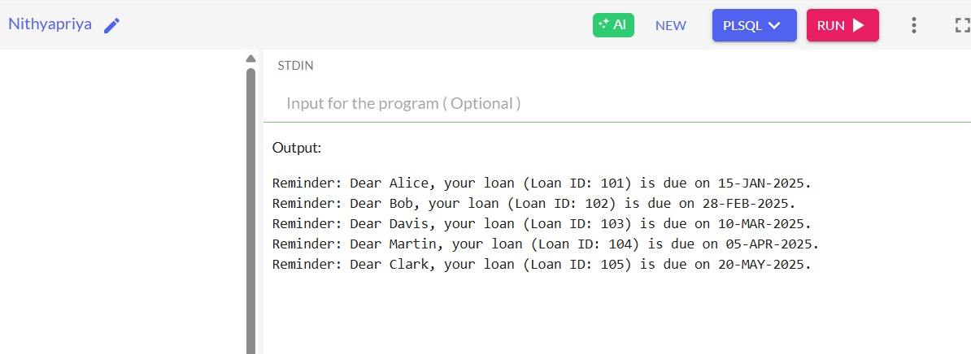

**Exercise 3: Stored Procedures**

**Scenario 1: The bank needs to process monthly interest for all savings accounts.**

**Code:**

CREATE TABLE accounts (

acc_id NUMBER PRIMARY KEY,

acc_name VARCHAR2(100),

bal NUMBER(10, 2),

type CHAR(1) -- 's' for savings, 'c' for checking

);

INSERT INTO accounts (acc_id, acc_name, bal, type) VALUES (1, 'Alice ', 10000.00, 's');

INSERT INTO accounts (acc_id, acc_name, bal, type) VALUES (2, 'Bob ', 150000.00, 's');

INSERT INTO accounts (acc_id, acc_name, bal, type) VALUES (3, ' Davis', 2000000.00, 's');

INSERT INTO accounts (acc_id, acc_name, bal, type) VALUES (4, 'Diana ', 5000.0, 'c');

INSERT INTO accounts (acc_id, acc_name, bal, type) VALUES (5, ' Clark', 800.00, 's');

CREATE OR REPLACE PROCEDURE PMI AS

BEGIN

UPDATE accounts

SET bal = bal + (bal * 0.01)

WHERE type = 's';

COMMIT;

END PMI;

/

EXEC PMI;

SELECT acc_id, bal, type FROM accounts;

**Output:**

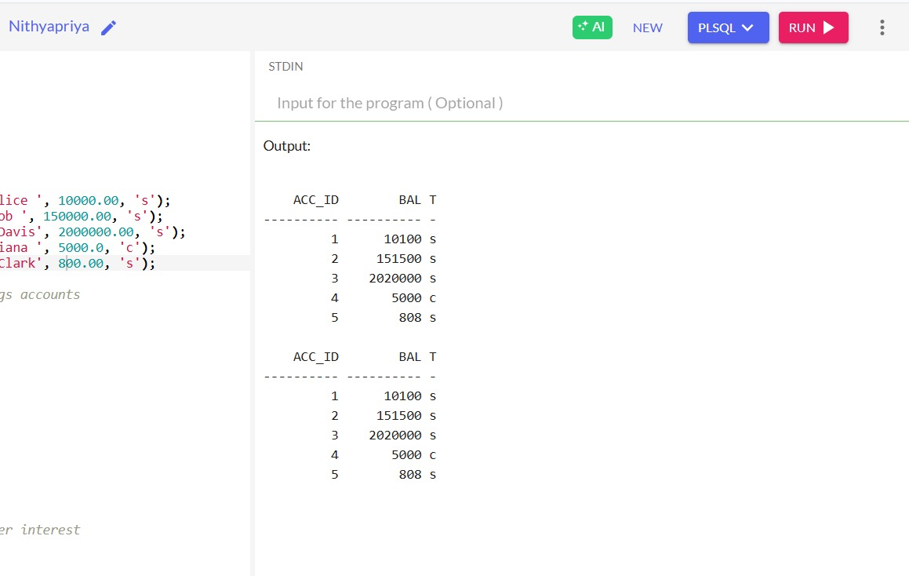

**Scenario 2: The bank wants to implement a bonus scheme for employees based on their**

**performance.**

**Code:**

CREATE TABLE emp (

emp_id INT PRIMARY KEY,

emp_name VARCHAR2(100),

sal NUMBER(10, 2),

dept INT

);

INSERT INTO emp (emp_id, emp_name, sal, dept) VALUES (1, 'John Doe', 50000.00, 101);

INSERT INTO emp (emp_id, emp_name, sal, dept) VALUES (2, 'Jane Smith', 60000.00, 102);

INSERT INTO emp (emp_id, emp_name, sal, dept) VALUES (3, 'Robert Brown', 55000.00, 101);

INSERT INTO emp (emp_id, emp_name, sal, dept) VALUES (4, 'Emily White', 45000.00, 103);

INSERT INTO emp (emp_id, emp_name, sal, dept) VALUES (5, 'Michael Green', 70000.00, 102);

CREATE OR REPLACE PROCEDURE UEB(d IN INT, b IN NUMBER) AS

BEGIN

UPDATE emp

SET sal = sal + (sal * b / 100)

WHERE dept = d;

COMMIT;

END UEB;

/

EXEC UEB(101, 10);

SELECT emp_id, sal, dept FROM emp;

**Output:**

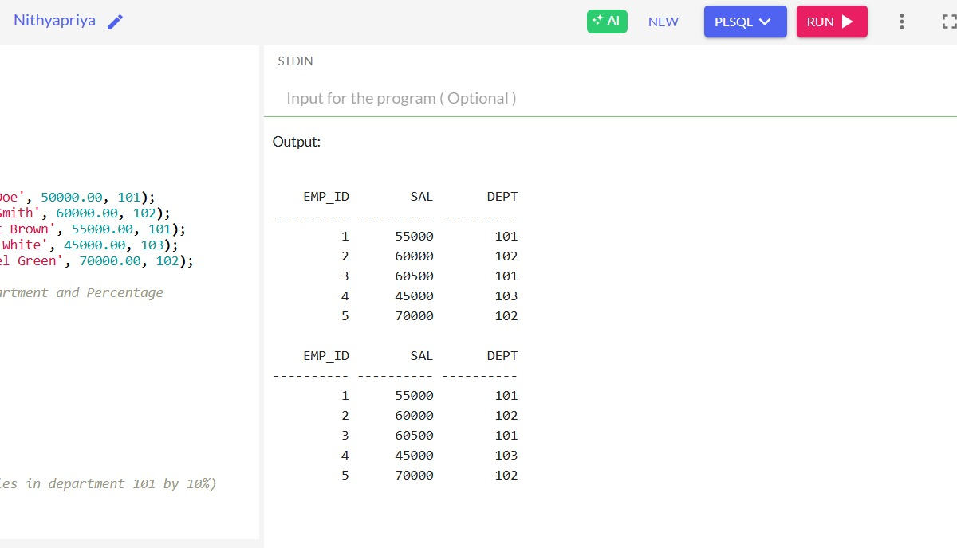

**Scenario 3: Customers should be able to transfer funds between their accounts.**

**Code:**

CREATE TABLE acc (

id INT PRIMARY KEY,

name VARCHAR2(100),

bal DECIMAL(10, 2)

);

INSERT INTO acc (id, name, bal) VALUES (1, 'Alice', 8000.00);

INSERT INTO acc (id, name, bal) VALUES (2, 'Nithya', 2000.00);

INSERT INTO acc (id, name, bal) VALUES (3, 'Davis', 78900.00);

INSERT INTO acc (id, name, bal) VALUES (4, 'Martin', 23400.00);

INSERT INTO acc (id, name, bal) VALUES (5, 'Ethan', 56400.00);

CREATE OR REPLACE PROCEDURE TF(f IN INT, t IN INT, a IN DECIMAL) AS

b DECIMAL(10, 2);

BEGIN

SELECT bal INTO b FROM acc WHERE id = f;

IF b >= a THEN

UPDATE acc SET bal = bal - a WHERE id = f;

UPDATE acc SET bal = bal + a WHERE id = t;

END IF;

COMMIT;

END TF;

/

EXEC TF(1, 2, 1000);

SELECT id, bal FROM acc;

**Output:**

